### [A Five-Wheeled Spinning Ferris Wheel](https://papercraftetc.blogspot.com/2014/08/a-five-wheeled-spinning-ferris-wheel.html)

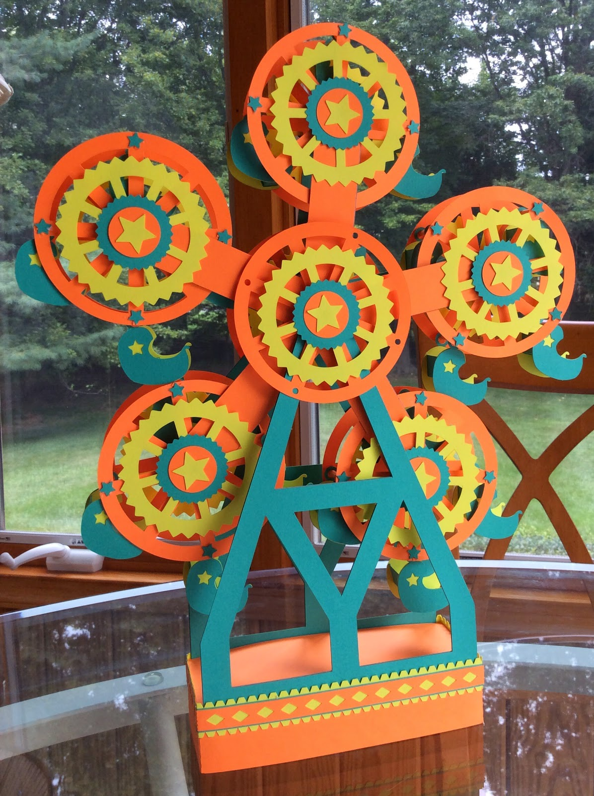

Five-wheeled Ferris Wheel

This is the last Ferris Wheel in the series that I am going to design. Initially I was going to make just four wheels and then I decided that it was not aesthetically pleasing to the eye so I made a five-wheeled Ferris Wheel. I think it turned out marvelously.  
Use the instructions from a previous post to assembly this model.  
<http://papercraftetc.blogspot.com/2014/07/whats-more-exciting-than-paper-ferris.html>In addition, a center stabilizer is included in this model. This is optional because I thought its addition would make a studier model. I did not include the instructions because it is a simple cylinder shape that is glued together. Please note, the wheels need to be aligned in the center so that they turn properly, so be careful when gluing.

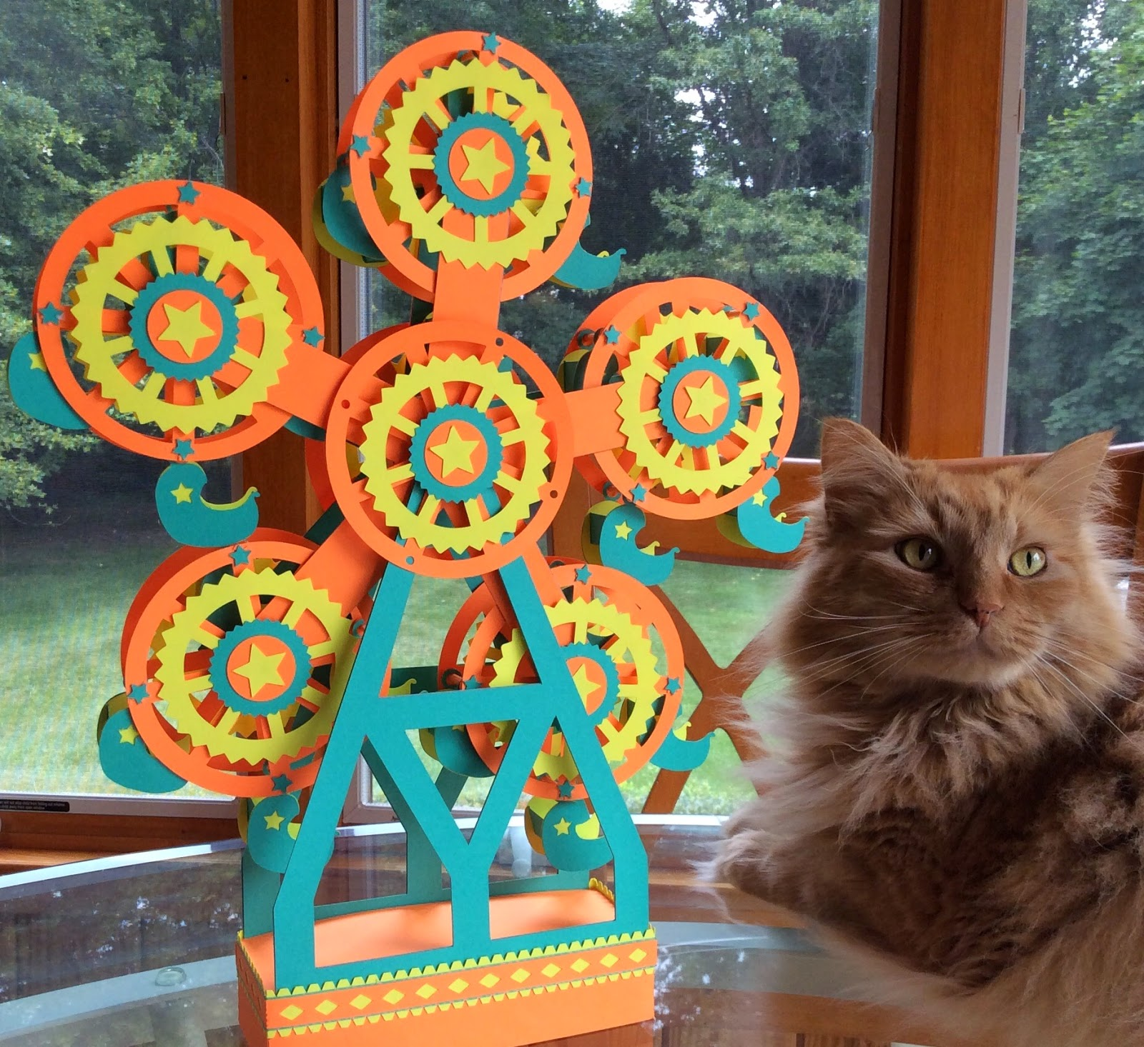

Of course, Marley wants to be in the picture.